3. Follow the service-oriented analysis and service-oriented design stages of the SOA delivery lifecycle to design an example services of your choice for Bama Tea.

Agile strategy is a combination of top-down and bottom-up approaches

### Start at the Top: The Global-View

It's made up of a group of functions represented in a hierarchical map, from the top down. This map will consist of all the functions needed to run this tea chain, such as production, hiring, marketing, supply chain, etc. Each function is decomposed into the high-level processes that make up that function, then each of these high-level processes can be decomposed into more granular ones.

The accounting process could be divided into simpler sub-processes such as creating an electronic invoice , validate XML document and metadata check. Even creating an electronic invoice could be divided into even more granular steps, that includes assigning accounting clerk, ideal storage conditions, etc.

### Bottom-up: Re-design

Address the need for a cohesive experience flow between the business itself as well as the end users.It's a process that pulls from many different sources—like user experience, product management, and marketing—in order to create and optimize powerful experiences that can be delivered seamlessly. And re-design, re-develop, re-test, re-deploy from the bottom.

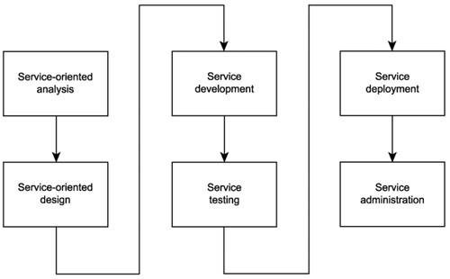

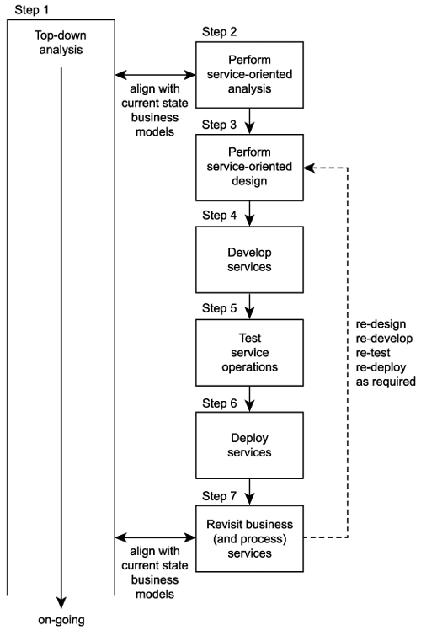

4. Suggest suitable development technologies.

Establish a global common SOA plan flexible enough to support the dynamics of Bama Tea’s business, by separating business functions from business process flow (the sequence of the business functions to be performed).

Try to separate the physical locations of business data from those of the business functions using the data, and user interfaces from the business process flow, business functions, and business data.